Antibiotic Stewardship Program Planning Worksheet

AVMA Convention 2024

# Main Conclusions

These are the top three items I want to discuss with my team regarding antibiotic stewardship.

1. _________________________________________________________________________________________
2. _________________________________________________________________________________________
3. _________________________________________________________________________________________

# General Approach

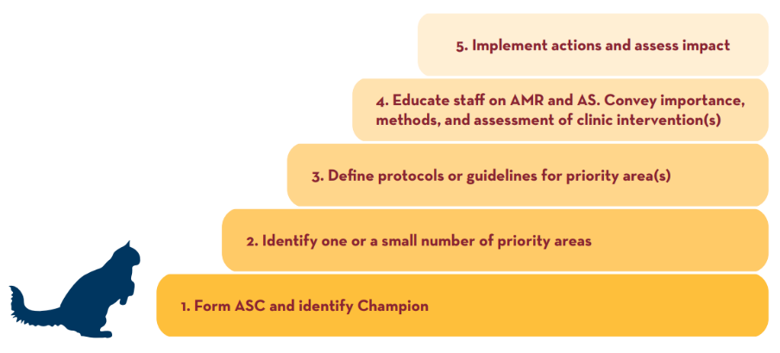

Below are things I know about my clinic’s capacity and outlook for stewardship activities.

**Resources**

|  |  |
| --- | --- |
| □ There ***are no*** staff or financial resources to support stewardship activities in my clinic right now.   * I can review the list of “basic” interventions and identify some that are feasible. * I can begin to advocate for what I think is needed (e.g., dedicated staff time, client communications support). * _______________________________________ * _______________________________________ | □ There ***are*** staff and/or financial resources to support stewardship activities in my clinic right now.   * I can review the checklist of interventions and identify some that are feasible for our team. * I can develop an antibiotic stewardship plan, outlining objectives for the next _______ years. * _______________________________________ * _______________________________________ |

**Scope**

|  |  |
| --- | --- |
| □ I want to focus our actions related to all five core principles on a **single common condition**.   * Our team will discuss the condition on which to focus. * We already know that we need to focus our attention on _________________, including use of diagnostics, drug use (e.g., selection, duration), and client communication. * _______________________________________ * _______________________________________ | □ I want to focus on applying general stewardship approaches in the clinic, with the goal of changing prescribing behaviors that impact multiple conditions.   * I will identify resources to help understand prescribing behavior. * I will make available treatment guidelines that address multiple conditions. * _______________________________________ * _______________________________________ |

**Education Approach — Staff**

|  |  |
| --- | --- |
| □ Our clinic leaders have the knowledge and capacity to provide education to staff.   * _______________________________________ * _______________________________________ * _______________________________________ | □ We will need to identify a resource for staff education.   * _______________________________________ * _______________________________________ * _______________________________________ |

**Education Approach — Clients**

|  |  |
| --- | --- |
| □ Our clinic leaders have the knowledge and capacity to develop materials to educate clients.   * _______________________________________ * _______________________________________ * _______________________________________ | □ We will need to identify a resource for client education materials.   * _______________________________________ * _______________________________________ * _______________________________________ |

# Specific Actions

Identify at least one way that your clinic will meet each core principle. Examples are provided.

|  |  |
| --- | --- |
| **Core Principle** | **Specific Action** |
| **Commit to stewardship:**  e.g., Form an antibiotic stewardship committee with one veterinarian champion and one technician, reflecting role and hours/month in job descriptions.  e.g., Email clients committing to antibiotic use only when needed, hang commitment posters in exam rooms, engage in special communication during U.S. Antibiotic Awareness Week, each November 18–24. |  |
| **Advocate for a system of care to prevent common diseases:**  e.g., Discuss as a team the conditions for which antibiotics are commonly used and identify one on which to focus.  e.g., Increase knowledge and awareness of infection prevention and the importance of preventing hospital-associated infections by holding a lunch and learn with a veterinary preventionist or by reviewing as a team the guidance on infection prevention published by the American Animal Hospital Association. |  |
| **Select and use antimicrobial drugs judiciously:**  e.g., Give each veterinarian a copy of the Pocket Guide: Antimicrobial Prescribing for Common Small Animal Diseases (<https://arsi.umn.edu/pocketguide>), and post one in the pharmacy area.  e.g., Hold a lunch and learn to review published guidelines from the International Society for Companion Animal Infectious Diseases (ISCAID). |  |
| **Evaluate antimicrobial drug use practices:**  e.g., In the context of published ISCAID guidelines, review prescribing practices for common conditions during a routine or special meeting of staff veterinarians, considering the use of diagnostics and potential approaches, such as “watchful waiting.”  e.g., Select a single condition (e.g., canine UTI) and a timeframe (e.g., 3 months) and review diagnostic and prescribing practices retrospectively.  e.g., Select a single condition (e.g., canine UTI) and a timeframe (e.g., 3 months) and track diagnostic and prescribing practices prospectively. |  |
| **Educate and build expertise:**  e.g., Hold a lunch and learn on antibiotic stewardship, using recorded presentations or an invited speaker.  e.g., Highlight stewardship continuing education at state and national veterinary continuing education conferences and encourage staff to attend. |  |

[](arsi.umn.edu)